SIMATS ENGINEERING (SAVEETHA SCHOOL OF ENGINEERING)
Department of Artificial Intelligence and Data Science ASSESSMENT TOOL 3 – Mock Interview

Course Code: | DSA03 | Course Title: | Natural Language Processing
CO Assessed: | CO5 – Articulation | Assessment: | Assessment Tool 3 – Mock Interview
Weightage: | 30% of CIA
CO5 Statement: | Implement semantic models using predicate logic, word sense disambiguation and validate information retrieval techniques. (BL-5)
Student Name: | D.Devin Pakianath | Reg. No.: | 192325003
Section / Batch: | 2023AI&ML | Date: | 01-09-2026

Code of Conduct
I D.Devin Pakianath(192325003) (Name / Reg No) certify that this submission is my original work and that I have adhered to the guidelines specified for this assessment. I understand that any violation of academic integrity rules will result in disciplinary action.
Signature of the Student: D.Devin

Instructions
- Start the mock interview by entering the provided ChatGPT prompt exactly as given in the Annexure A in the next page. Enter your Name and Register Number when requested.
- Answer all 10 interview questions independently and in your own words using mobile chatgpt voice. Do not copy content from external sources or use AI-generated responses during the interview.
- Provide detailed and meaningful answers with appropriate technical terminology, examples, and justifications wherever applicable. One-line answers may lead to lower scores.
- Complete the interview in a single session. Ensure that all 10 questions are answered before requesting the final evaluation and assessment report.
- Submit the final ChatGPT-generated report printout, including the interview questions, your responses, question-wise rubric evaluation, and the Student Average Final Mark, as proof of completion.
- Duration: 30 minutes.

Section / Topic | Focus | Question No.
Discourse & Reference Resolution | Understanding discourse, anaphora resolution, reference tracking, and contextual interpretation in text | Q1
Text Coherence & Discourse Structure | Analyzing coherence relations, discourse organization, and maintaining meaningful text flow | Q2
Dialog Acts & Interpretation | Identifying dialog acts, speaker intentions, and conversational meaning | Q3
Dialog and Conversational Agents | Architecture, components, and working of conversational agents/chatbots | Q4
Language Generation Architecture | Stages of Natural Language Generation (NLG), pipeline architecture, and applications | Q5
Surface Realization & Discourse Planning | Transforming semantic representations into grammatically correct sentences and planning discourse | Q6
Machine Translation – Transfer Approach | Translation process using transfer-based methods and practical applications | Q7
Machine Translation – Interlingua Approach | Language-independent representation and multilingual translation framework | Q8
Statistical Approaches in NLP | Statistical language models, probability-based language generation, and machine translation | Q9
Integrated Case Study (Analytical & Problem Solving) | Real-world scenario involving discourse analysis, conversational agents, language generation, and machine translation | Q10

Annexure A – Mock Interview

CHATGPT PROMPT: copy and paste in your chatgpt
MOCK INTERVIEW ASSESSMENT – NLP (Language Generation and Discourse Analysis)
Act as an expert Technical Interview Panel for Computer Science and Engineering students.
Interview Domain:
Language Generation and Discourse Analysis Topics:
- Discourse
- Reference Resolution
- Text Coherence
- Discourse Structure
- Coherence
- Dialog and Conversational Agents
- Dialog Acts
- Interpretation
- Language Generation
- Architecture
- Surface Realization
- Discourse Planning
- Machine Translation
- Transfer Metaphor
- Interlingua
- Statistical Approaches
Interview Instructions:
Step 1:
Ask the student to enter:
Student Name:
Register Number:
Step 2:
Conduct a technical interview consisting of exactly 10 questions.
Rules:
- Ask only one question at a time.
- Wait for the student's response.
- Ask conceptual, analytical, application-based, and problem-solving questions.
- Include at least:
o 2 questions on Discourse and Coherence o 2 questions on Conversational Agents and Dialog Acts o 2 questions on Language Generation o 2 questions on Machine Translation o 2 analytical or scenario-based questions
Step 3:
Store every question and answer.
Step 4:
After Question 10, evaluate the student using the following rubric.
RUBRIC
Technical Knowledge (25) Level 4:
Demonstrates strong and accurate subject knowledge with in-depth understanding
Level 3:
Shows good knowledge with minor gaps
Level 2:
Basic knowledge with noticeable errors
Level 1:
Lacks fundamental technical knowledge
Problem Solving (25) Level 4:
Solves problems logically and applies concepts effectively in real scenarios
Level 3:
Applies concepts with moderate accuracy
Level 2:
Limited problem-solving ability; requires guidance
Level 1:
Unable to solve or apply concepts
Analytical Thinking (20) Level 4:
Analyzes questions critically and provides well-structured logical answers
Level 3:
Provides reasonable analysis with some structure
Level 2:
Superficial or partially structured responses
Level 1:
No analytical thinking demonstrated
Communication (15) Level 4:
Communicates clearly, confidently and professionally using appropriate terminology
Level 3:
Communicates well with minor hesitation
Level 2:
Communication lacks clarity or confidence
Level 1:
Unable to communicate effectively
Confidence (15) Level 4:
Displays high confidence, positive attitude and professional behavior throughout
Level 3:
Shows good confidence with minor issues
Level 2:
Low confidence and inconsistent behavior
Level 1:
Lacks confidence and professionalism
MARK CALCULATION
Level 4 = 100% of weightage
Level 3 = 75% of weightage
Level 2 = 50% of weightage
Level 1 = 25% of weightage
Technical Knowledge = 25 marks
Problem Solving = 25 marks
Analytical Thinking = 20 marks
Communication = 15 marks Confidence = 15 marks
Calculate:
Final Score = Sum of all rubric scores
Step 5:
Generate the final report in the exact format below.

MOCK INTERVIEW ASSESSMENT REPORT
Student Name:M.Rishitha
Register Number:192424335
INTERVIEW QUESTIONS AND RESPONSES
Q1:
Question Asked: What is discourse in Natural Language Processing? How is it different from a single sentence?

Student Response:
Discourse in NLP means understanding and analyzing a group of sentences that are connected to each other and form a meaningful conversation or text.
A single sentence expresses one idea, while discourse contains multiple sentences where the meaning of one sentence may depend on the previous or following sentences.
Example: “Ravi went to the shop. He bought some fruits.”
Here, the word “He” refers to Ravi. Understanding this requires looking at both sentences, so it is discourse processing.
Q2:
Question Asked Explain the importance of context in discourse processing.
Student Response:
Context is very important in discourse processing because the meaning of a sentence can change depending on the situation or previous sentences.
For example:
“Rahul went to the bank. He deposited some money.”
Here, context tells us that “bank” means a financial institution.
Context helps NLP systems to:
- Understand the correct meaning of words.
- Resolve references such as “he”, “she”, and “it”.
- Understand conversations correctly.
- Identify the relationship between sentences
Q3:
Question Asked What is reference resolution? Why is it important in NLP?
Student Response:
Reference resolution is the process of finding what a word or phrase refers to in a sentence or conversation.
For example:
“Priya bought a book. She read it at night.”
Here, “She” refers to Priya and “it” refers to the book.
It is important because it helps NLP systems understand the actual meaning of a text or conversation and maintain the correct context.

Q4:
Question Asked Explain the difference between anaphora and cataphora with examples.
Student Response:
Anaphora occurs when a word refers to something that was already mentioned earlier.
Example:
“Ravi bought a phone. He likes it.”
Here, “He” refers to Ravi, which was mentioned before.
Cataphora occurs when a word refers to something that is mentioned later.
Example:
“When he arrived home, Ravi called his mother.” Here, “he” refers to Ravi, which is mentioned later.
Simple difference:
- Anaphora → reference goes backward.
- Cataphora → reference goes forward.

Q5:
Question Asked “Ravi told Arun that he had won the competition.” Why is reference resolution difficult in this sentence?
Student Response:
Reference resolution is difficult because the pronoun “he” can refer to either Ravi or Arun.
The sentence does not clearly tell us who won the competition.
It could mean:
- Ravi won the competition, or
- Arun won the competition.
Therefore, the NLP system needs additional context or information to determine the correct person.

Q6:
Question Asked What is a dialogue act? List any four types.
Answer:
A dialogue act is the purpose or function of a person's utterance in a conversation. It tells us what the speaker is trying to do.
Four types of dialogue acts are:
- Question – asking for information. Example: “What is your name?”
- Statement – giving information. Example: “My name is Ravi.”
- Request – asking someone to do something. Example: “Please open the door.”
- Greeting – starting a conversation politely.
Example: “Hello!”

Q7:
Question Asked What is a conversational agent? Give two examples.
Student Response:
A conversational agent is a computer program or AI system that communicates with people using natural language through text or speech.
It can understand user questions and provide suitable responses.
Examples:
- ChatGPT
- Google Assistant

Q8:
Question Asked What is coherence and how does it contribute to meaningful communication?
Student Response:
Coherence means that the ideas in a text or conversation are logically connected and easy to understand.
For example:
“Ravi was hungry. He went to a restaurant and ordered food.” These sentences are coherent because the ideas are connected logically.
Coherence helps communication by:
- Connecting different ideas.
- Making the text easier to understand.
- Helping the reader follow the flow of information.
- Making the overall message meaningful.

Q9:
Question Asked What is discourse structure?
Student Response:
Discourse structure refers to the way sentences, ideas, and conversations are organized and connected to each other.
It shows how different parts of a text or conversation are related.
For example, a conversation may have the structure:
Greeting → Question → Answer → Closing
Understanding discourse structure helps NLP systems understand the overall meaning and flow of a conversation or text.
Q10:
Question Asked. What is text coherence?
Student Response:

Text coherence means that the sentences and ideas in a text are logically connected and make sense as a whole.
For example:
“Ravi studied hard for the exam. He prepared notes and practiced questions. Therefore, he scored good marks.”
The ideas are connected logically, so the text is coherent.
In simple words:
Text coherence makes a piece of writing clear, organized, and meaningful to the reader.

RUBRIC EVALUATION
Criterion Weightage Assigned Level Marks Awarded
Technical Knowledge 25 | Level X | XX
Problem Solving 25 | Level X | XX
Analytical Thinking 20 | Level X | XX
Communication 15 | Level X | XX
Confidence 15 | Level X | XX
SUMMARY TABLE
Technical Problem Analytical Communication Confidence SubQ Student Avg
Knowledge (25) Solving (25) Thinking (20) (15) (15) Total Final Mark Level X Level X Level X Level X Level X XX.X XX.X
OVERALL FEEDBACK
Strengths:
- List strengths
Areas for Improvement:
- List improvements
Interview Readiness:
- Excellent / Good / Average / Needs Improvement
End the report after the Interview Readiness section.
After evaluating each answer, do NOT display the marks immediately.
Store the evaluation internally.
After Question 10 is completed:
- Generate a Question-wise Evaluation Table for all 10 questions.
- For each question assign:
- Technical Knowledge Level
- Problem Solving Level
- Analytical Thinking Level
- Communication Level
- Confidence Level
- SubQ Total
- Calculate SubQ Total using:
Level 4 = 100% weightage
Level 3 = 75% weightage
Level 2 = 50% weightage
Level 1 = 25% weightage
- Calculate Student Avg Final Mark as:

Average of all 10 SubQ Totals
- Display:
- Complete interview questions
- Student answers
- Question-wise evaluation table
- Student Avg Final Mark
- Overall strengths
- Areas for improvement
- Interview readiness
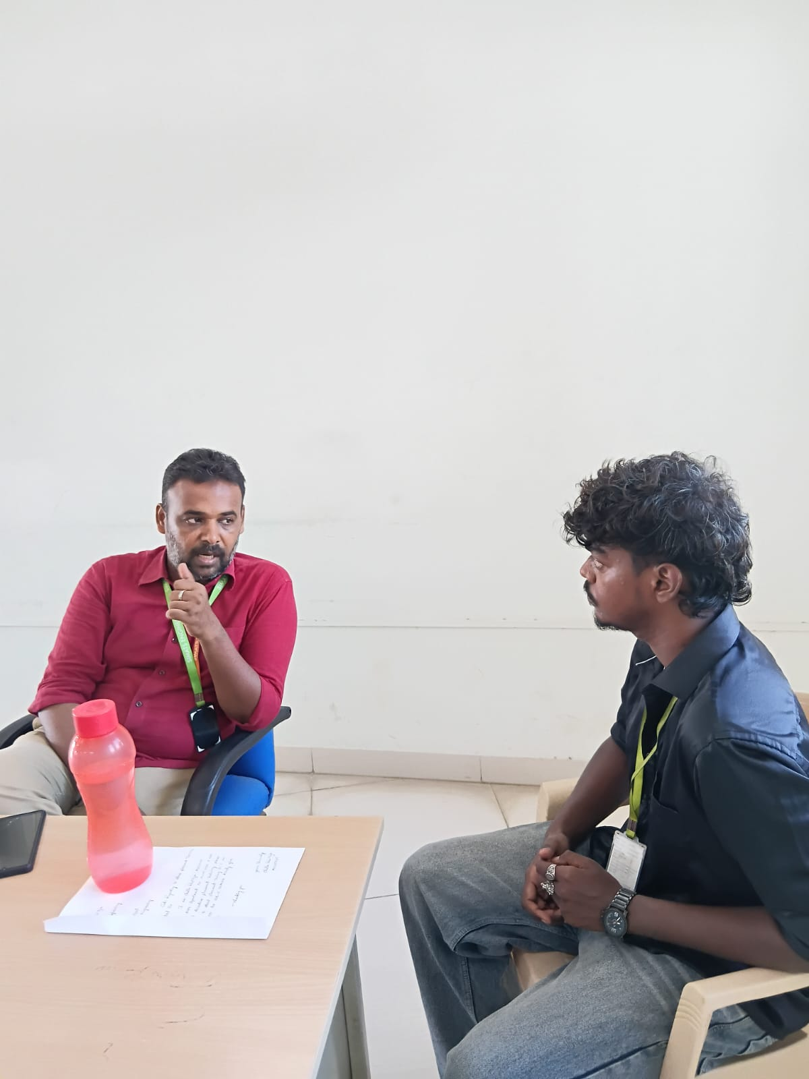

Rubrics for Calculation

Criteria | Weigh tage | Level 4 (Exemplary) | Level 3 (Proficient) | Level 2 (Developing) | Level 1 (Beginning)
Technical Knowledge | 25 | Demonstrates strong and accurate subject knowledge with indepth understanding | Shows good knowledge with minor gaps | Basic knowledge with noticeable errors | Lacks fundamental technical knowledge
Problem Solving | 25 | Solves problems logically and applies  concepts effectively in real scenarios | Applies concepts with moderate accuracy | Limited problemsolving ability; requires guidance | Unable to solve or apply concepts
Analytical Thinking | 20 | Analyzes questions critically and provides  well-structured, logical answers | Provides reasonable  analysis with some structure | Superficial or partially  structured responses | No analytical thinking demonstrated
Communic ation | 15 | Communicates clearly, confidently, and  professionally with proper terminology | Communicates well with minor hesitation | Communication lacks clarity or confidence | Unable to communicate effectively
Confidence | 15 | Displays high confidence, positive attitude, and  professional behavior throughout | Shows good confidence with minor issues | Low confidence; inconsistent behavior | Lacks confidence and  professionalism

Q. No. / Criteria  Level | Problem Understanding | Algorithm Design | Use of  Control  Structures | Pseudoco de  Structure | Complet eness | Sub.  Total | Total  %
1 | 2 | 3 | 3 | 3 | 3 | 14 | 69
2 | 2 | 3 | 3 | 3 | 3 | 14
3 | 2 | 3 | 3 | 3 | 3 | 14
4 | 2 | 3 | 3 | 3 | 3 | 14
5 | 2 | 3 | 3 | 3 | 3 | 14
6 | 2 | 3 | 3 | 3 | 3 | 14
7 | 2 | 3 | 3 | 3 | 3 | 14
8 | 2 | 3 | 3 | 3 | 3 | 14
9 | 2 | 3 | 3 | 3 | 3 | 14
10 | 2 | 3 | 3 | 3 | 3 | 14

Faculty In-charge | Course Coordinator | Program Director
Dr. T. Kumaragurubaran
Signature: _______________ | Signature: _______________ | Signature: _______________
Date: ___________________ | Date: ___________________ | Date: ___________________

